Infrastructure Documentation

1. Virtual Machine Provisioning
A Windows Server 2022 virtual machine was provisioned on Google Cloud Platform using the company account (operations@cmcadvisor.com). Network firewall rules were configured to allow inbound traffic on port 443 (HTTPS) from external sources.
Google Cloud Console Access
- URL: https://console.cloud.google.com/compute/instancesDetail
- Username: operations@cmcadvisor.com
- Password: cmc@12345
- 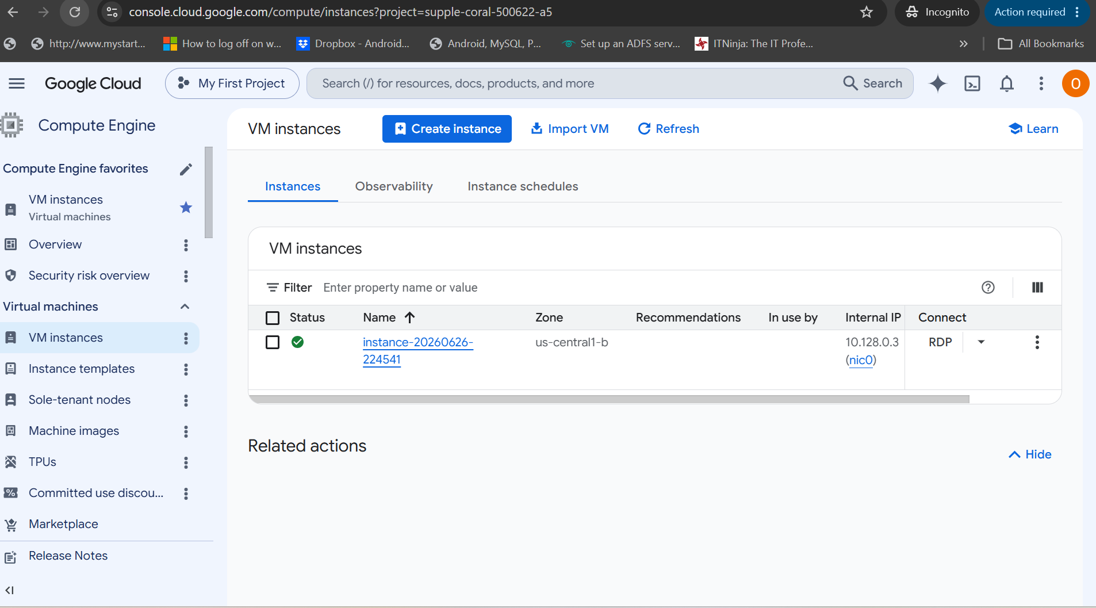
Remote Desktop Access
- Public IP: 34.63.43.131
- Username: rawahl
- Password: cmc@12345wax
and we have another user with name (operation),we can set the password form google cloud
Billing
The account is currently on a free-tier trial with a $300 credit, estimated to cover approximately two months of usage. After the trial period expires, the estimated monthly cost is $160/month.

2. Software Installation and Configuration
The following components were installed and configured on the VM:
A. IIS (Internet Information Services)
IIS has been installed and configured to serve web applications over HTTPS.
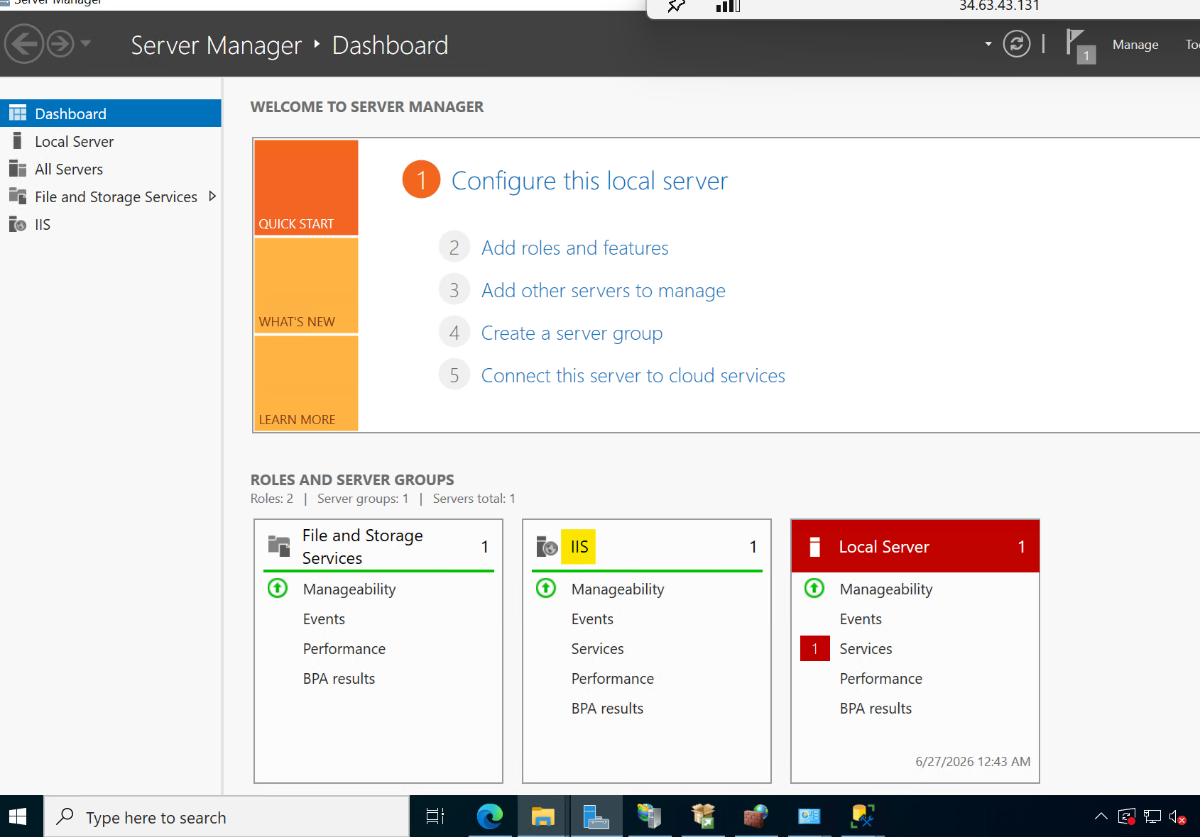
B. SQL Server 2022 Express
SQL Server 2022 Express has been installed along with SQL Server Management Studio (SSMS).
- Authentication: SQL Server Authentication (SA account)
- SA Password: cmc@12345
- Database: An empty database named rawahl_db has been created and is ready for use.
- 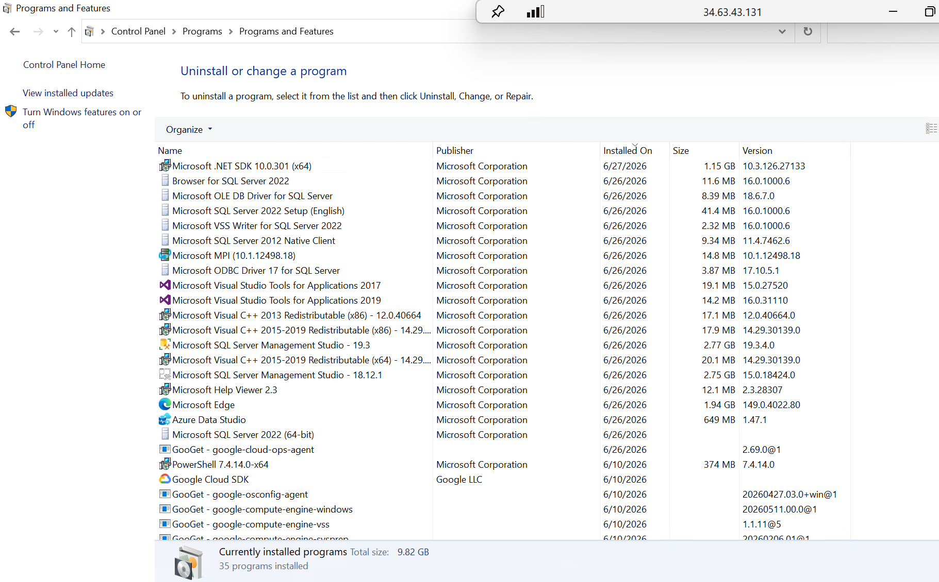
C. ASP.NET 10.0
The ASP.NET 10.0 runtime and hosting bundle have been installed to support application deployment on IIS.
D. SSL Certificate
Once the service setup is complete, an SSL certificate and DNS record will be purchased and configured for the domain.

